A
PROJECT REPORT ON
Design and Implementation of a Scalable Telecom Customer Churn Prediction and Retention Platform using PySpark and Machine Learning
IN PARTIAL FULFILLMENT OF
MASTER OF COMPUTER APPLICATION
BY
Divyesh S. Joshi
Seat No.: 52419
UNDER THE GUIDANCE OF
Prof. Yugandhara Patil
IN PARTIAL FULFILMENT OF
Award of the Degree of

MASTER OF COMPUTER APPLICATION
(SEM IV)
SUBMITTED TO

SAVITRIBAI PHULE PUNE UNIVERSITY THROUGH

YASHASWI EDUCATION SOCIETY’S
INTERNATIONAL INSTITUTE OF MANAGEMENT SCIENCE CHINCHWAD, PUNE
ACADEMIC YEAR 2025-26

DECLARATION

I, Divyesh S. Joshi, student of International Institute of Management Science, Chinchwad, Pune, hereby declare that this Industrial Project report entitled “Design and Implementation of Scalable ETL Pipeline for Telco Customer Churn Analysis using PySpark, PostgreSQL and Streamlit” is a bonafide record of work done by me for the partial fulfilment of the requirement for the degree of Master of Computer Application (M.C.A) through Savitribai Phule Pune University.
I, hereby, declare that I have adequately referenced the original sources and this is my original work. I also declare that I have adhered to all principles of academic honesty and integrity and have not misrepresented or fabricated or falsified any idea/data/fact/source in my submission. I understand that any violation of the above will be cause for disciplinary action by the Institute and can also evoke penal action from the sources which have thus not been properly cited or from whom proper permission has not been taken when needed.

(Signature)
Divyesh S. Joshi
IIMS, Chinchwad, Pune.

ACKNOWLEDGEMENT

I am deeply indebted towards my project guide Prof. Yugandhara Patil who gave me the opportunity and was instrumental in providing me all the knowledge and insight to do the research. It is their inspiration that has kept me motivated all along my project and the discipline and integrity they had expected from a mini project that made me to learn the real live projects.

I would like to express my earnest gratitude and thanks to Dr. Shivaji Mundhe (Director of IIMS) and my project guide Prof. Yugandhara Patil for providing me all the knowledge and skills, resources, technical support, guidance as required to achieve this Endeavour.
I thank my all-faculty members and friends for their support and blessings. The report is the result of contribution of numerous people to mention individually.
I also thank all respondent who have given their value time, views and authentic information for this mini project. I thank each and everybody who has contributed directly or indirectly to the successful completion of this project.

(Signature)
Divyesh S. Joshi
IIMS, Chinchwad, Pune.


CERTIFICATE

This is to Certify that Mr. Divyesh S. Joshi is a Bonafide Student of International Institute of Management Science, Chinchwad, Pune, worked on Industrial Project Title “Design and Implementation of Scalable ETL Pipeline for Telco Customer Churn Analysis using PySpark, PostgreSQL and Streamlit” has successfully completed project work in partial fulfillment for award of degree Master of Computer Application (MCA) Sem IV of Savitribai Phule Pune University. This report is the record of Student’s own efforts under our supervision and guidelines.

Date:

Prof. Yugandhara Patil Dr Ashwini Brahme Dr. Shivaji Mundhe
Internal Guide HOD-MCA Director, IIMS, Chinchwad

Internal Examiner External Examiner
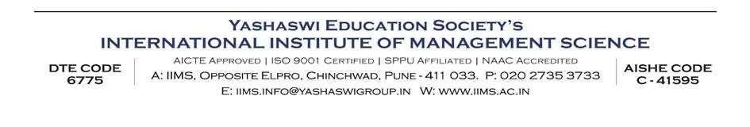

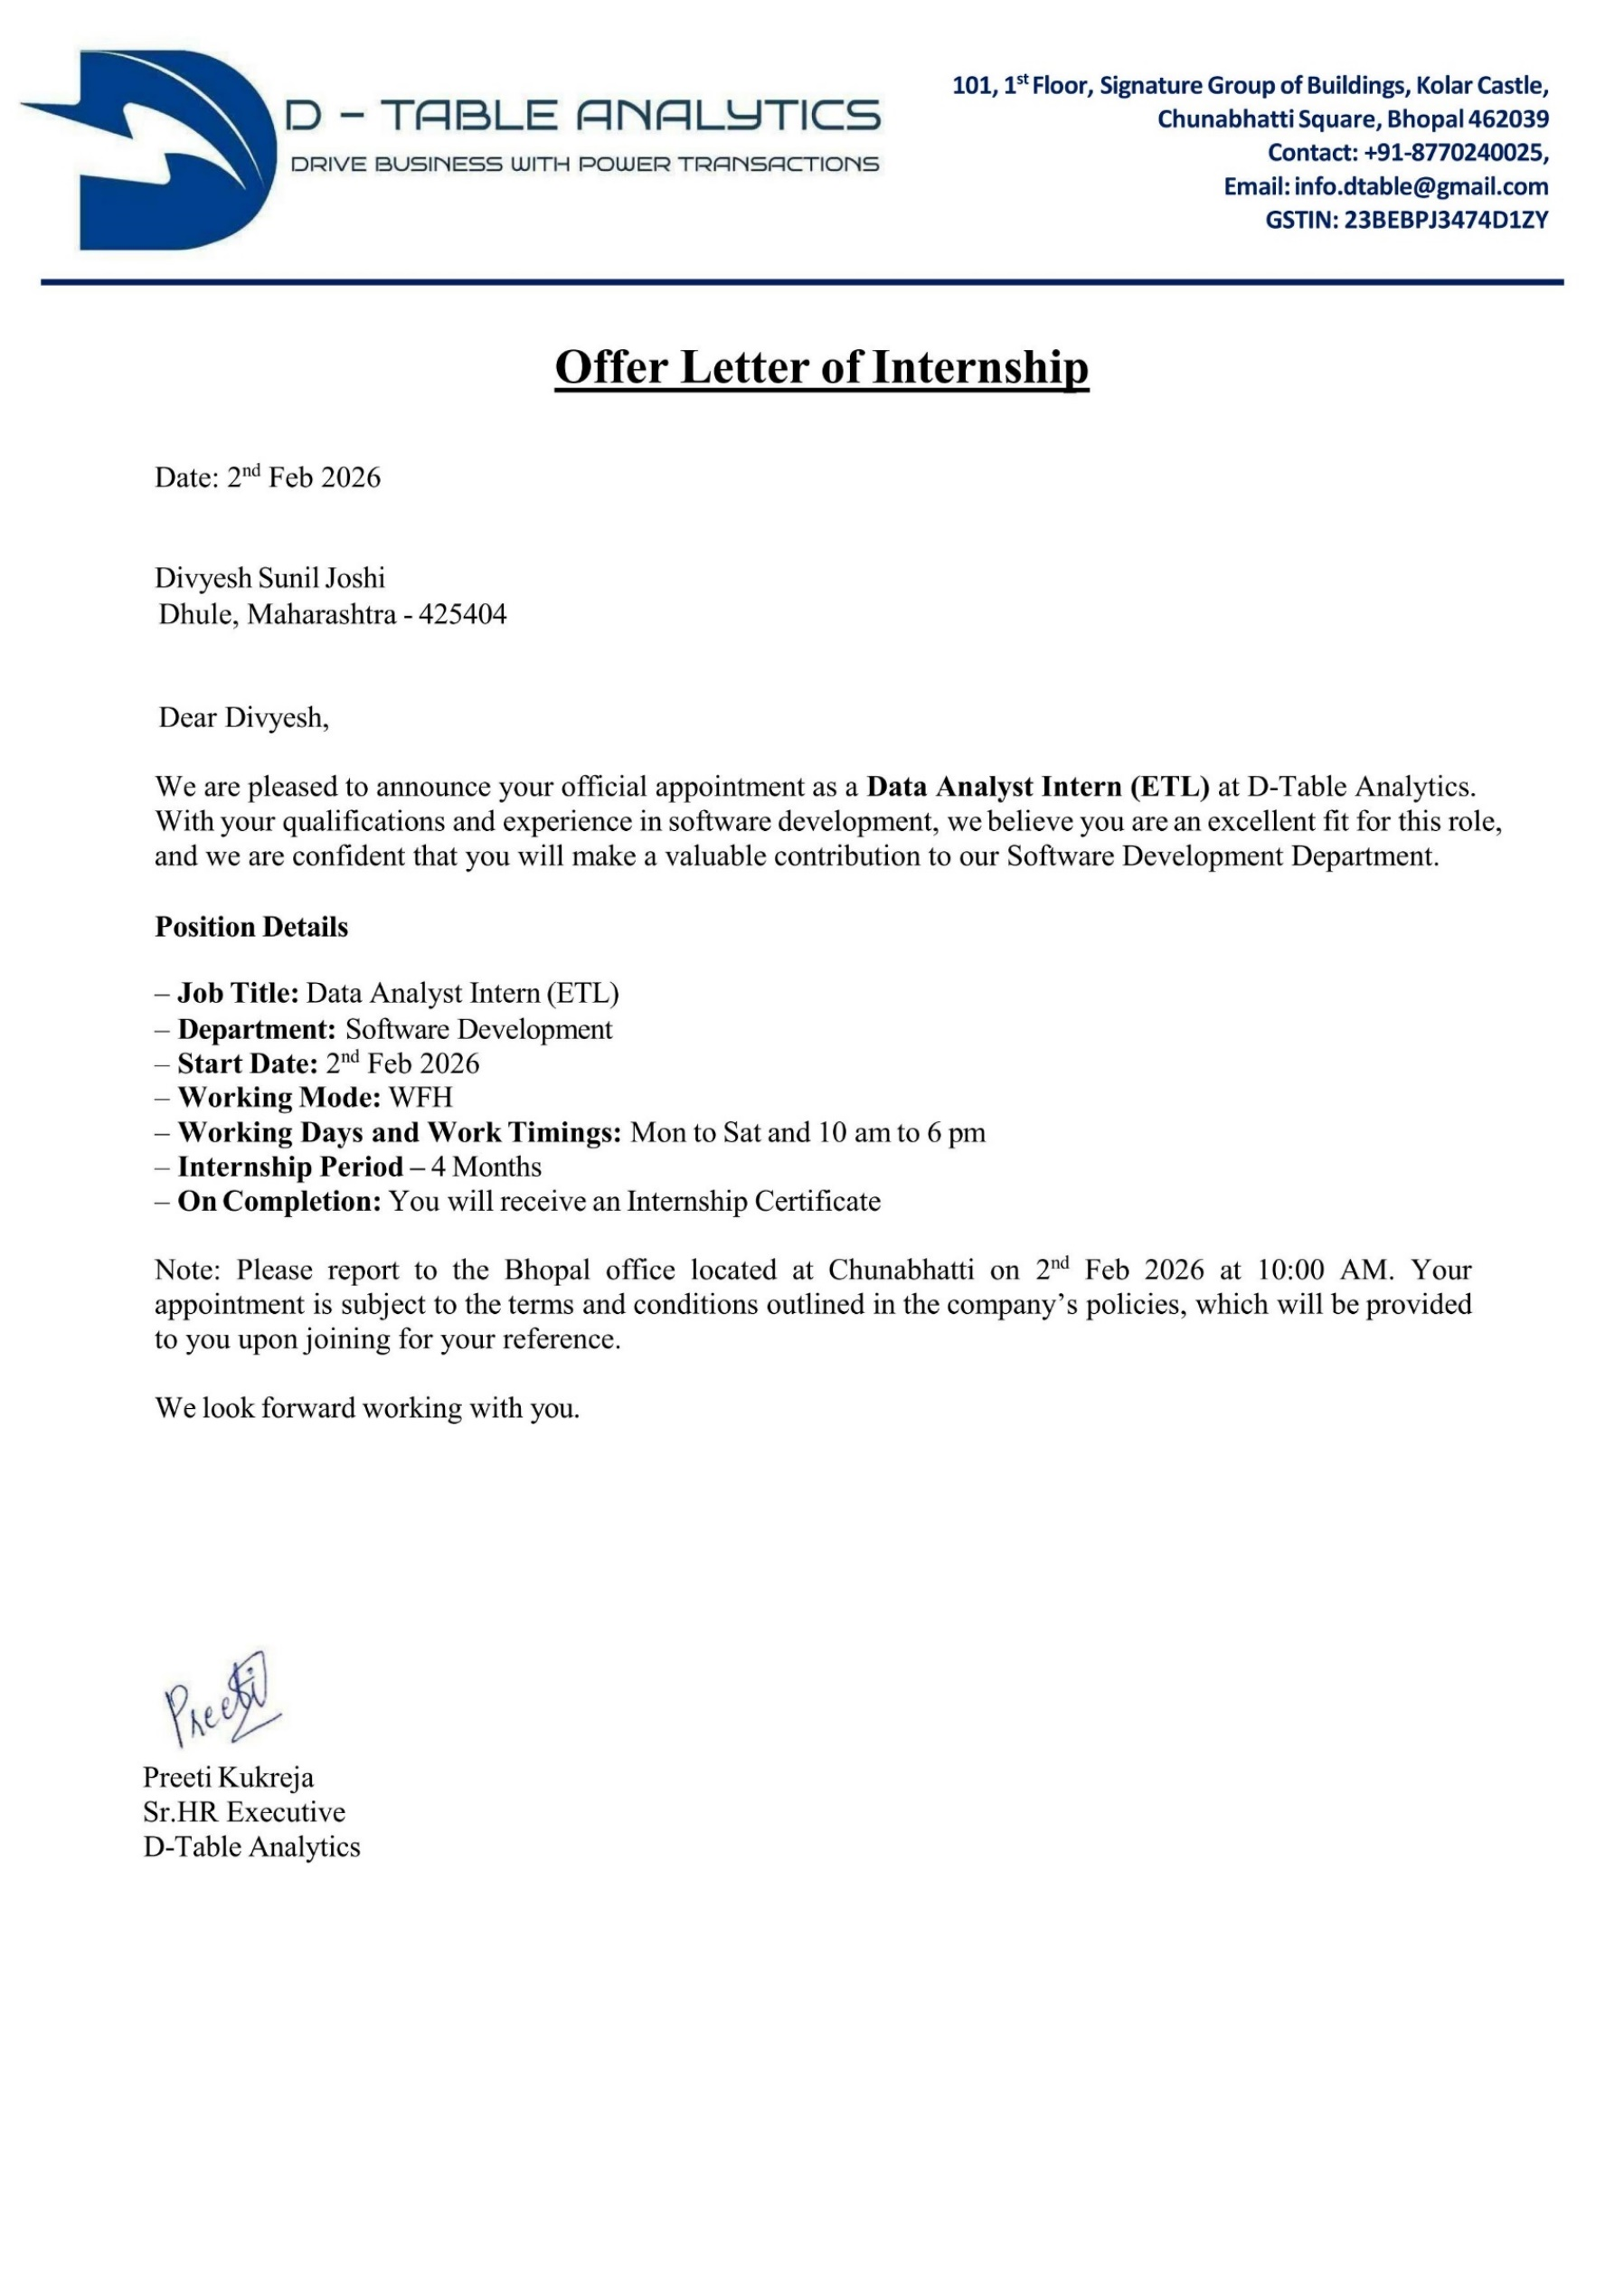
Project Completion letter
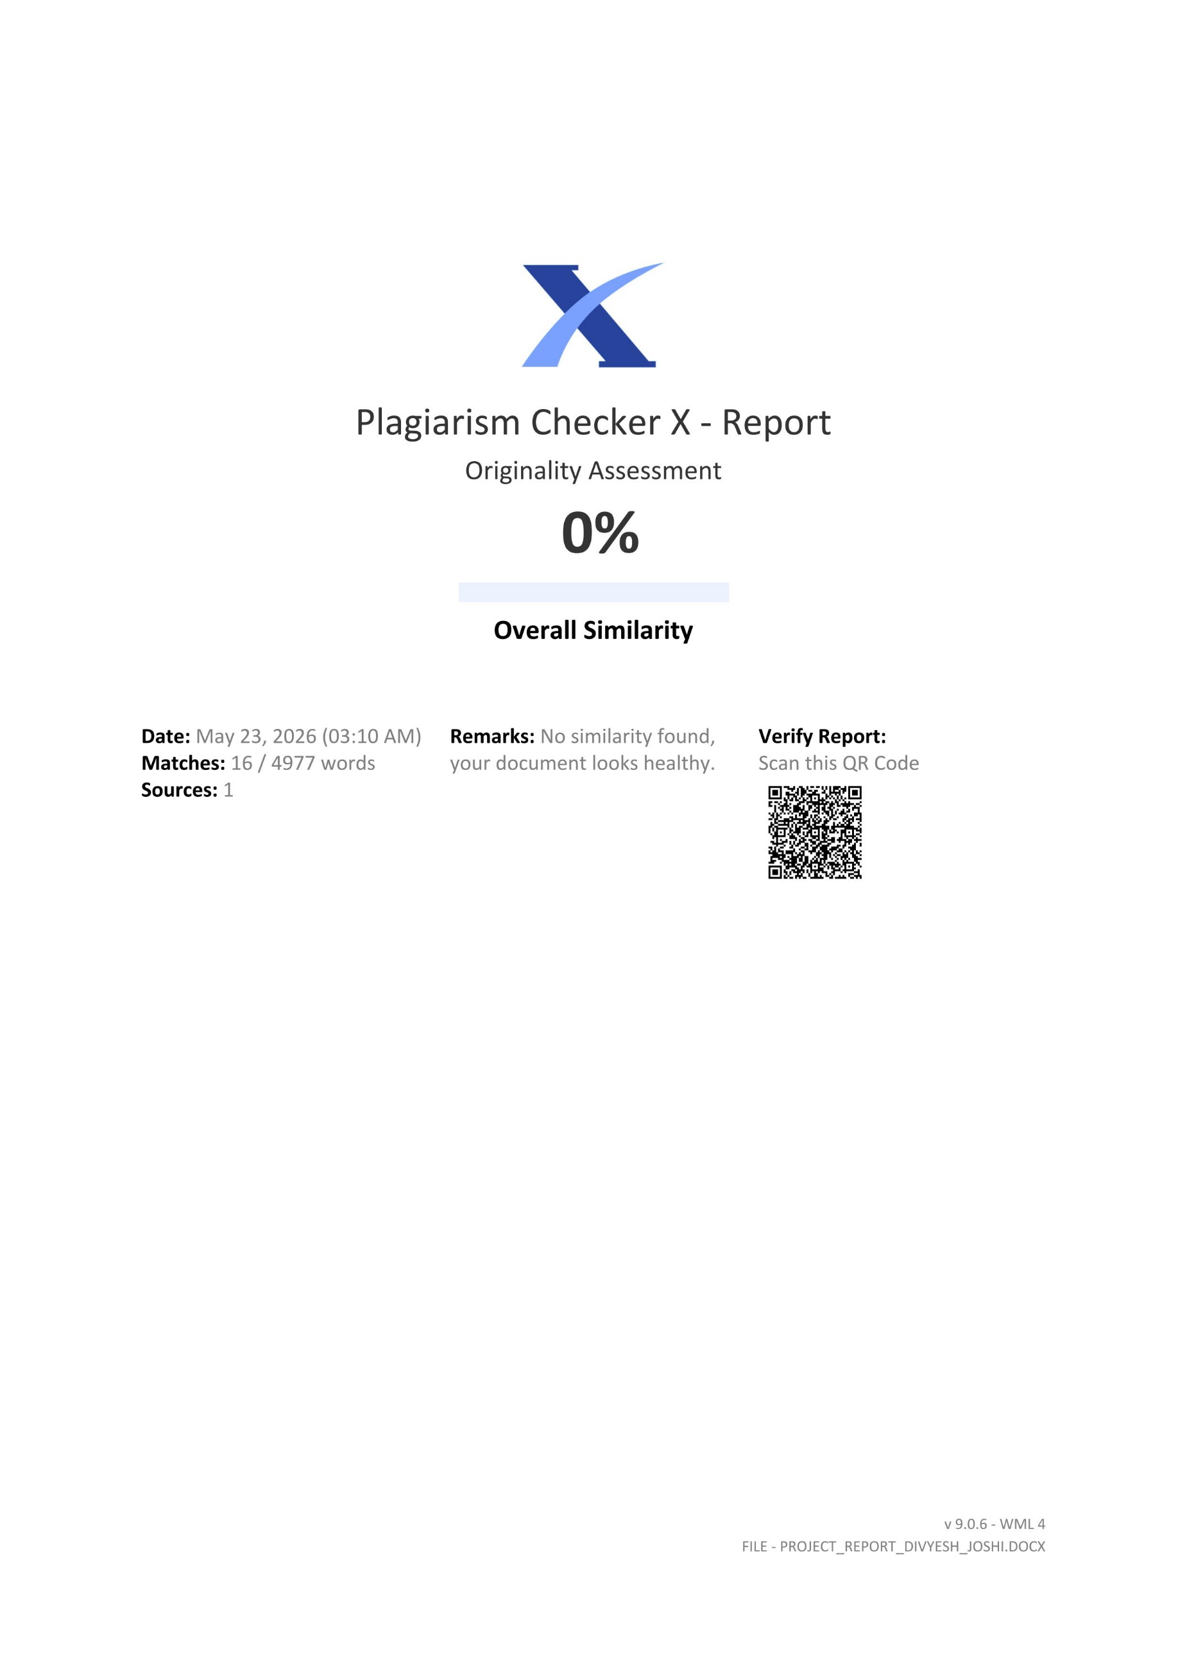
Plagarism Report

